# ASSIGNMENT 1-DAA

**1. Two Sum**

Given an array of integers nums and an integer target, return *indices of the two numbers such*

*that they add up to target*.

You may assume that each input would have *exactly* one solution, and you may not use the *same*

element twice.

You can return the answer in any order.

Coding:

intp = input("Enter the elements separated by spaces")  
nums = list(map(int, intp.split()))  
t = int(input("Enter the target element"))  
for i in range(len(nums) - 1):  
 if nums[i] + nums[i + 1] == t:  
 print("[", i, ",", i + 1, "]")

Output:

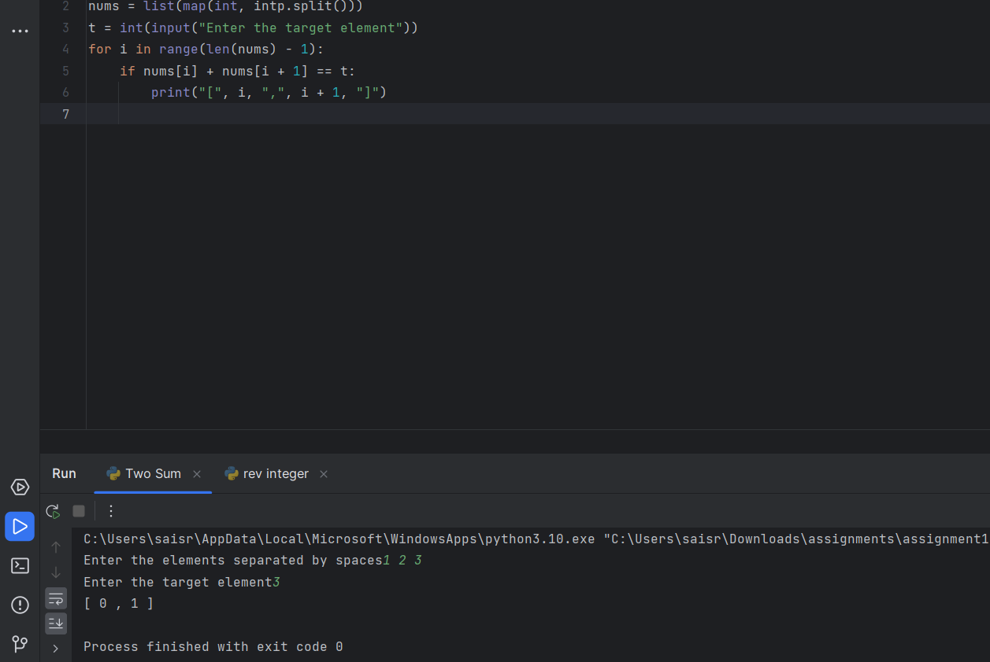

**2.Add Two Numbers**

You are given two non-empty linked lists representing two non-negative integers. The digits are

stored in reverse order, and each of their nodes contains a single digit. Add the two numbers and

return the sum as a linked list.

You may assume the two numbers do not contain any leading zero, except the number 0 itself.

Coding

class ListNode:  
 def __init__(self, val=0, next=None):  
 self.val = val  
 self.next = next  
  
def add(l1,l2):  
 dummy = ListNode()  
 curr = dummy  
 carry = 0  
  
 while l1 or l2:  
 val1 = l1.val if l1 else 0  
 val2 = l2.val if l2 else 0  
  
 total = val1 + val2 + carry  
 carry = total // 10  
 digit = total % 10  
  
 curr.next = ListNode(digit)  
 curr = curr.next  
  
 l1 = l1.next if l1 else None  
 l2 = l2.next if l2 else None  
  
 if carry:  
 curr.next = ListNode(carry)  
  
 return dummy.next  
  
def create(values):  
 dummy = ListNode()  
 curr = dummy  
 for val in values:  
 curr.next = ListNode(val)  
 curr = curr.next  
 return dummy.next  
  
  
l1 = create([2, 4, 3])  
l2 = create([5, 6, 4])  
  
result = add(l1,l2)  
while result:  
 print(result.val,end="")  
 result=result.next

Output

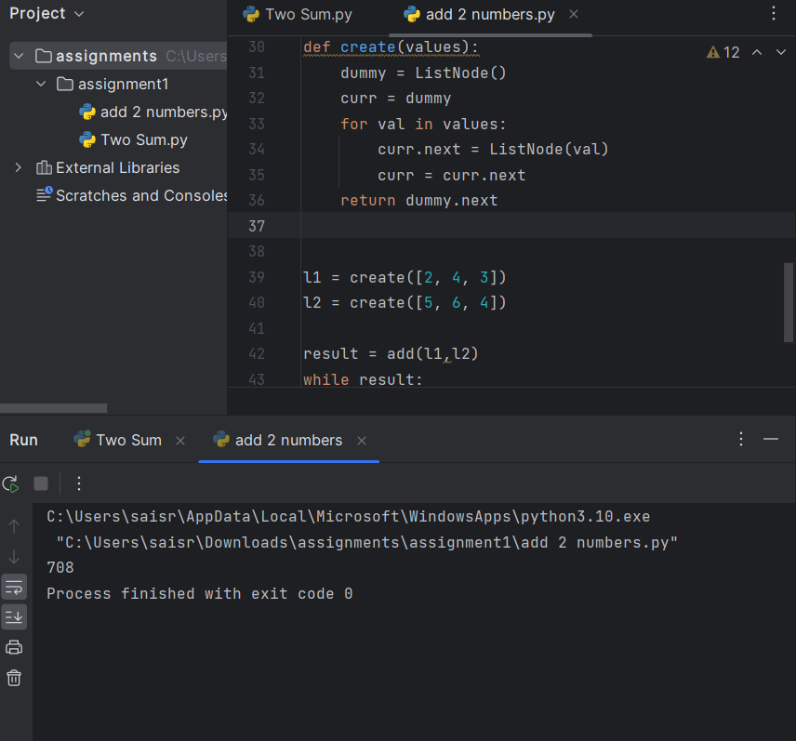

**3. Longest Substring without Repeating Characters**

Given a string s, find the length of the longest substring without repeating characters.

Coding

s1 = str(input("Enter a string with spaces"))  
s = list(s1.split())  
l = []  
m=0  
for c in s:  
 if c not in l:  
 l.append(c)  
 m = max(m,len(l))  
 else:  
 l=l[l.index(c)+1:]  
 l.append(c)  
print(len(l))

Output:

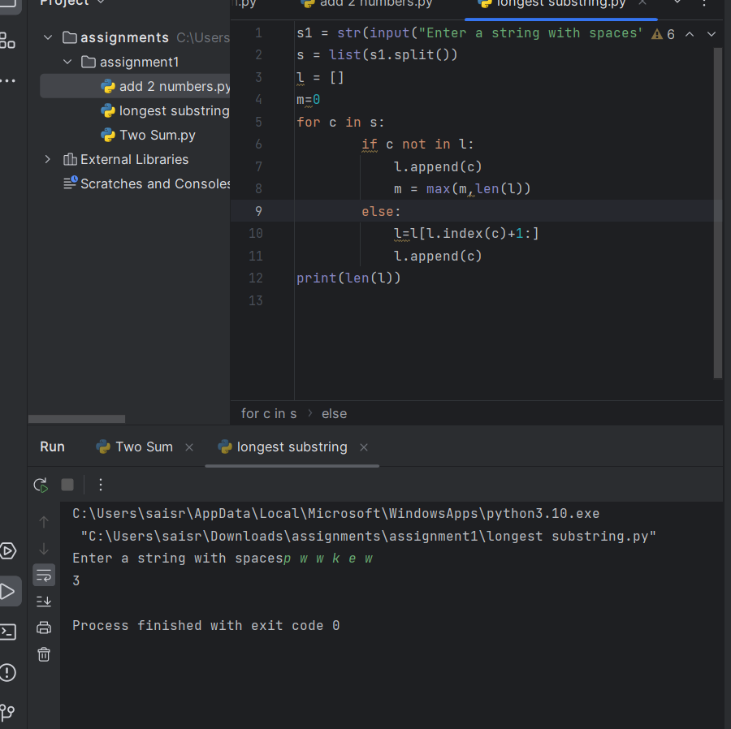

**4. Median of Two Sorted Arrays**

Given two sorted arrays nums1 and nums2 of size m and n respectively, return the median of the

two sorted arrays.

The overall run time complexity should be O(log (m+n))

Coding:

num1 = [1,3]  
num2 = [2]  
num1.extend(num2)  
num1.sort()  
n = len(num1)  
  
if n % 2 == 0:  
 median = (num1[n//2 - 1] + num1[n//2]) / 2  
else:  
 median = num1[n//2]  
  
print(median)

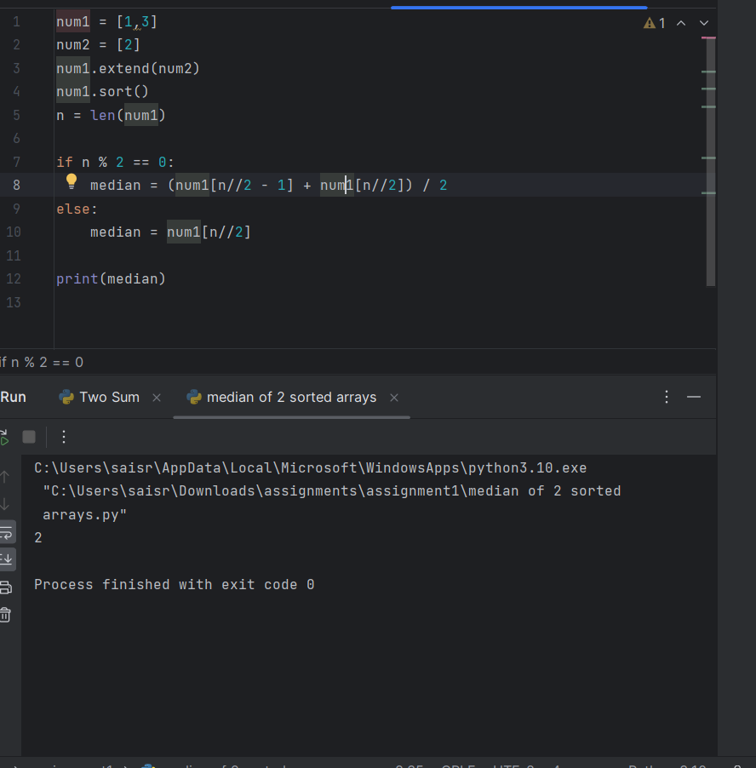

**5. Longest Palindromic Substring**

Given a string s, return *the longest palindromic substring* in s.

Example 1:

Input: s = "babad"

Output: "bab"

Explanation: "aba" is also a valid answer.

def is_pali(s):  
 return s == s[::-1]  
  
longest_palindrome = ""  
s = input("Enter a string")  
for i in range(len(s)):  
 for j in range(i+1,len(s)-1):  
 sub = s[i:j]  
 if is_pali(sub) and len(sub) > len(longest_palindrome):  
 longest_palindrome = sub  
  
print("Longest palindrome substring:", longest_palindrome)

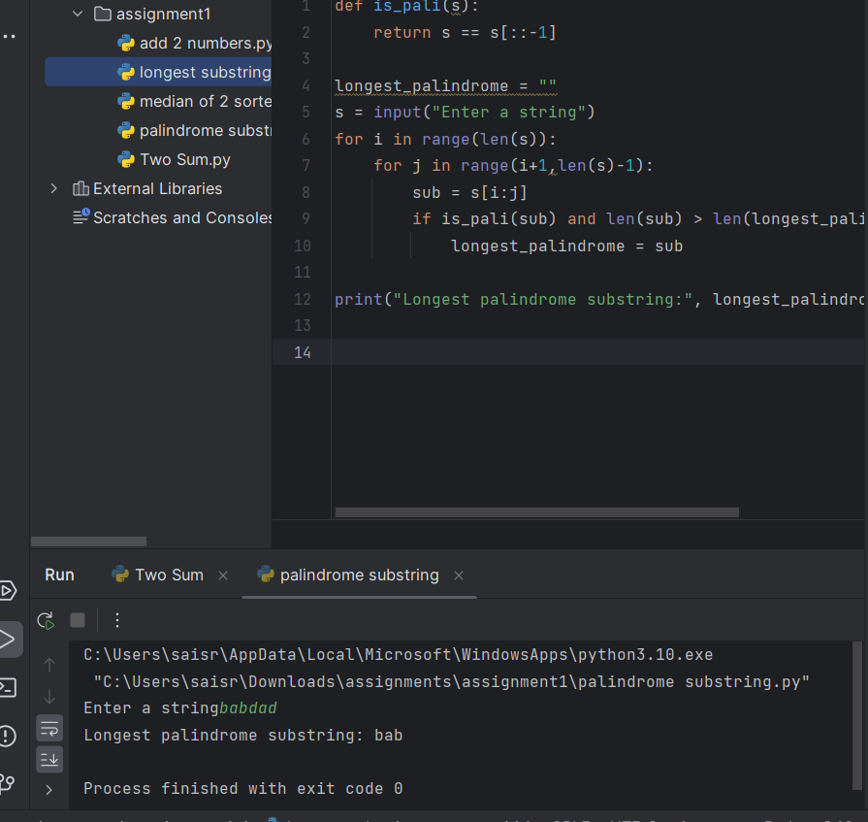

**6. Zigzag Conversion**

**The string "PAYPALISHIRING" is written in a zigzag pattern on a given number of rows**

**like this: (you may want to display this pattern in a fixed font for better legibility)**

**P A H N**

**A P L S I I G**

**Y I R**

**And then read line by line: "PAHNAPLSIIGYIR"**

**Write the code that will take a string and make this conversion given a number of rows:**

**string convert(string s, int numRows);**

def convert(s, numRows):  
 if numRows == 1 or numRows >= len(s):  
 return s  
  
 rows = [''] * numRows  
 index, step = 0, 1  
  
 for char in s:  
 rows[index] += char  
 if index == 0:  
 step = 1  
 elif index == numRows - 1:  
 step = -1  
 index += step  
  
 return ''.join(rows)  
  
s = "PAYPALISHIRING"  
numRows = 3  
print(convert(s, numRows))

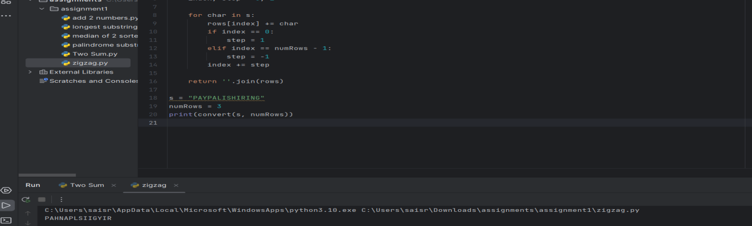

**7. Reverse Integer**

Given a signed 32-bit integer x, return x *with its digits reversed*. If reversing x causes the value

to go outside the signed 32-bit integer range [-231, 231 - 1], then return 0.

Assume the environment does not allow you to store 64-bit integers (signed or unsigned).

x = input("Enter a number: ")  
l = list(x)  
if l[0] != "-":  
 l1 = list(map(int, l[::-1]))  
 print(*l1, sep="")  
else:  
 l1 = list(map(int, l[1:][::-1]))  
 print("-", end="")  
 print(*l1, sep="")

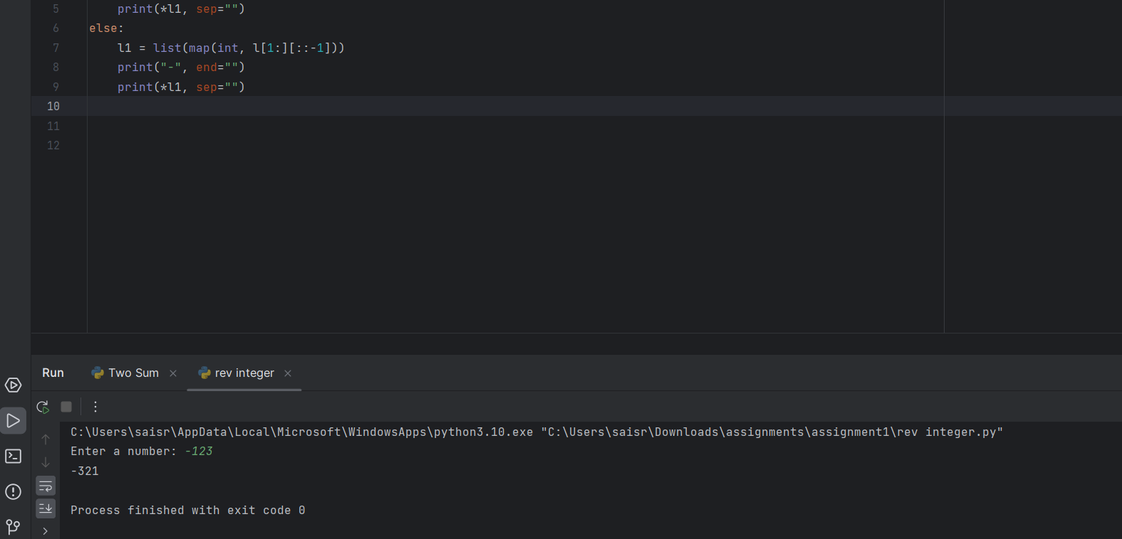

**8. String to Integer (atoi)**

Implement the myAtoi(string s) function, which converts a string to a 32-bit signed integer

(similar to C/C++'s atoi function).

Coding:

def myAtoi(s: str) -> int:  
 s = s.lstrip()  
  
 sign = 1  
 if s and (s[0] == '+' or s[0] == '-'):  
 if s[0] == '-':  
 sign = -1  
 s = s[1:]  
  
 num = 0  
 for char in s:  
 if not char.isdigit():  
 break  
 num = num * 10 + int(char)  
  
 num *= sign  
  
 INT_MAX = 2**31 - 1  
 INT_MIN = -2**31  
 if num > INT_MAX:  
 return INT_MAX  
 elif num < INT_MIN:  
 return INT_MIN  
 else:  
 return num  
  
s = "-42"  
print(myAtoi(s))  
  
s = "4193 with words"  
print(myAtoi(s))  
  
s = "words and 987"  
print(myAtoi(s)) # Output: 0

Output:

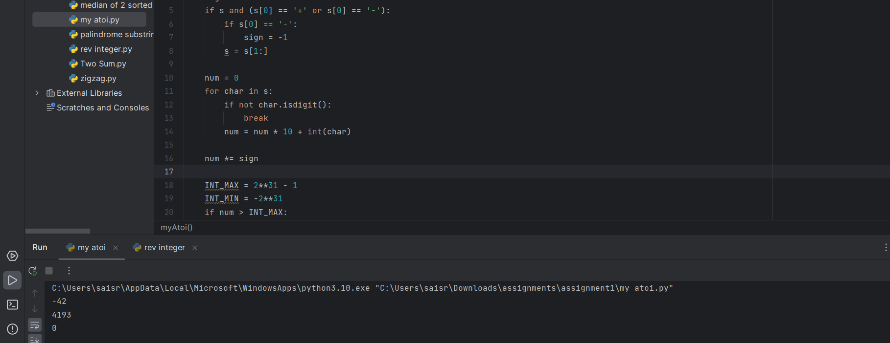

**9. Palindrome Number**

Given an integer x, return true *if* x *is a palindrome, and* false *otherwise*

def isPalindrome(x: int) -> bool:  
 return str(x) == str(x)[::-1]  
  
x = 121  
print(isPalindrome(x))   
  
x = -121  
print(isPalindrome(x))   
  
x = 10  
print(isPalindrome(x))

Output:

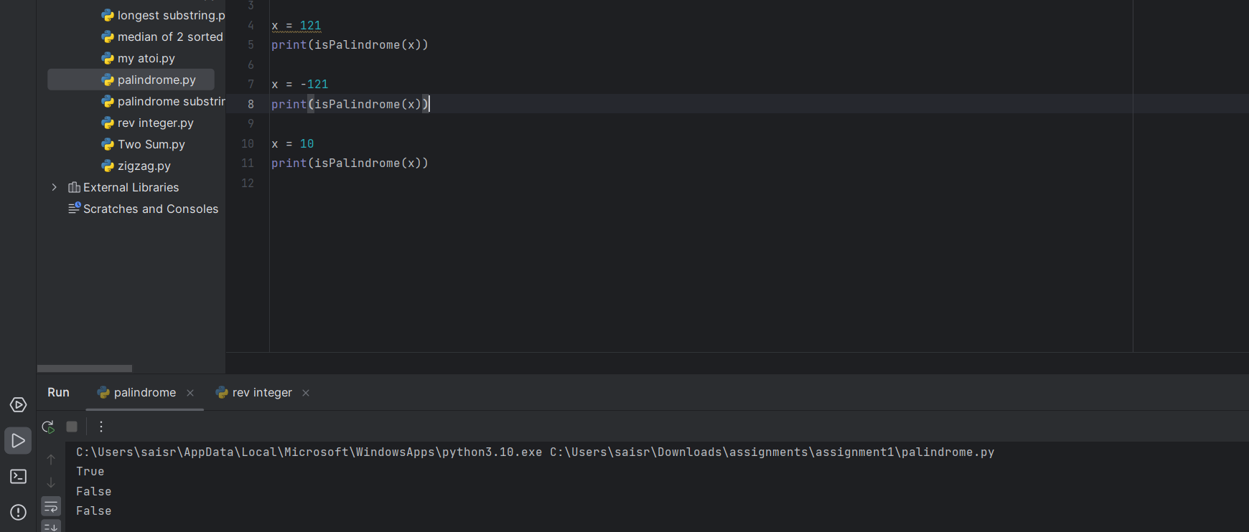

**10. Regular Expression Matching**

Given an input string s and a pattern p, implement regular expression matching with support for

'.' and '*' where:

● '.' Matches any single character.

● '*' Matches zero or more of the preceding element.

The matching should cover the entire input string (not partial)

Coding:

def isMatch(s: str, p: str) -> bool:  
 dp = [[False] * (len(p) + 1) for _ in range(len(s) + 1)]  
 dp[0][0] = True  
  
 for j in range(1, len(p) + 1):  
 if p[j - 1] == '*':  
 dp[0][j] = dp[0][j - 2]  
  
 for i in range(1, len(s) + 1):  
 for j in range(1, len(p) + 1):  
 if p[j - 1] == '.' or p[j - 1] == s[i - 1]:  
 dp[i][j] = dp[i - 1][j - 1]  
 elif p[j - 1] == '*':  
 dp[i][j] = dp[i][j - 2] or (dp[i - 1][j] and (s[i - 1] == p[j - 2] or p[j - 2] == '.'))  
  
 return dp[-1][-1]  
  
s = "aa"  
p = "a*"  
print(isMatch(s, p))   
  
s = "mississippi"  
p = "mis*is*p*."  
print(isMatch(s, p))

Output:

